**Grand Hotel (Mediterranean See View)**

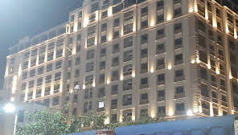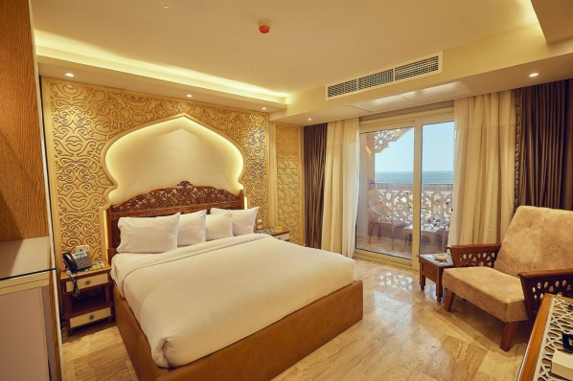

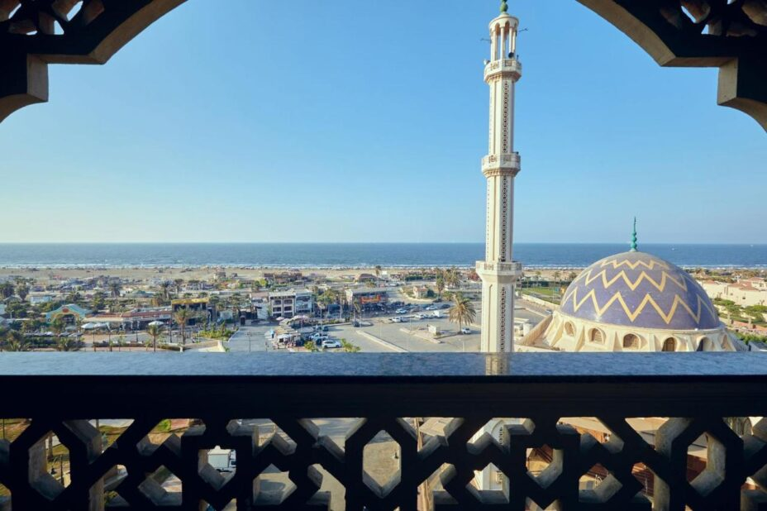 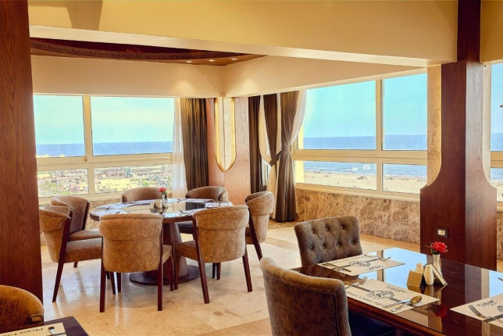

**Single Room (1100.00 EP)**

**Double Room (1800.00 EP)**

**Triple Room (2500.00 EP)**

**Port Said Hotel (Mediterranean See and Suez Canal View)**

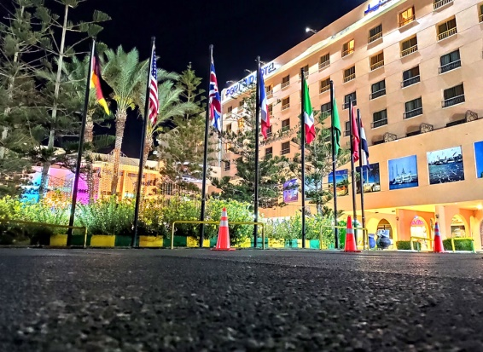 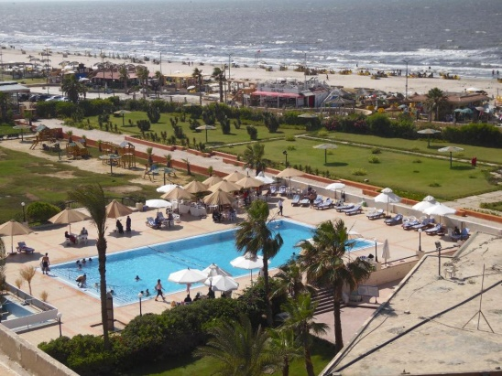 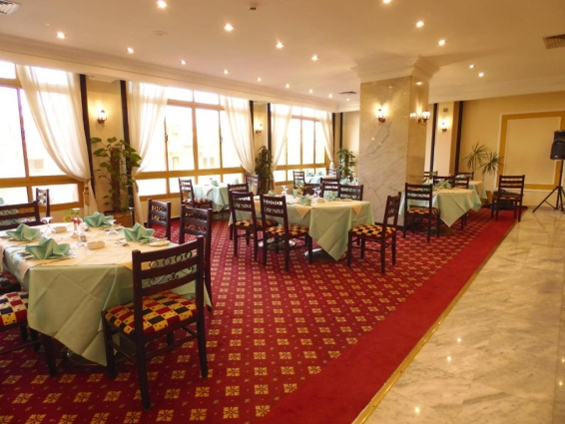 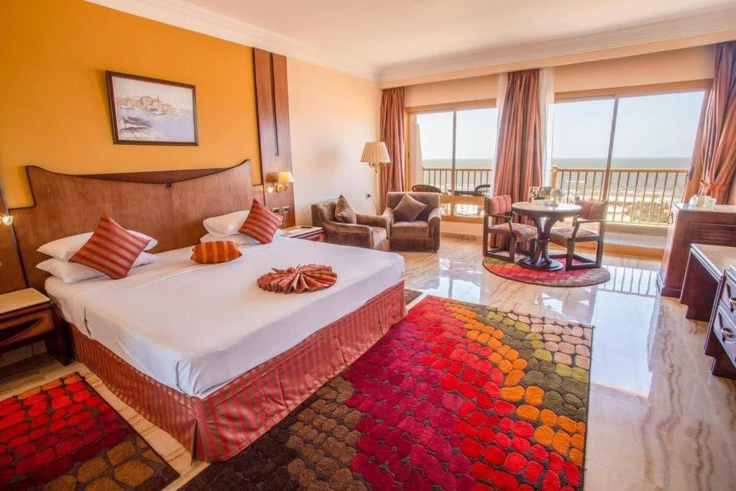

**Single Room (1800.00 EP)**

**Double Room (2400.00 EP)**

**Triple Room (2800.00 EP)**

**Resta Hotel (Mediterranean See and Suez Canal View)**

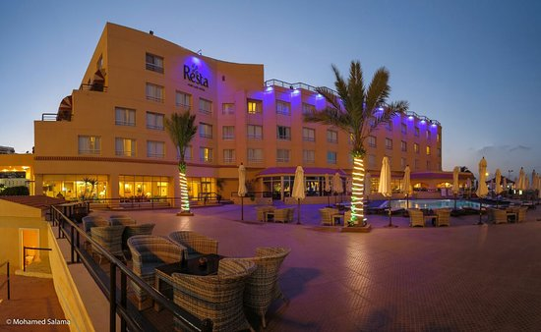

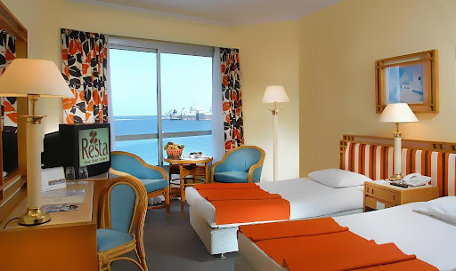

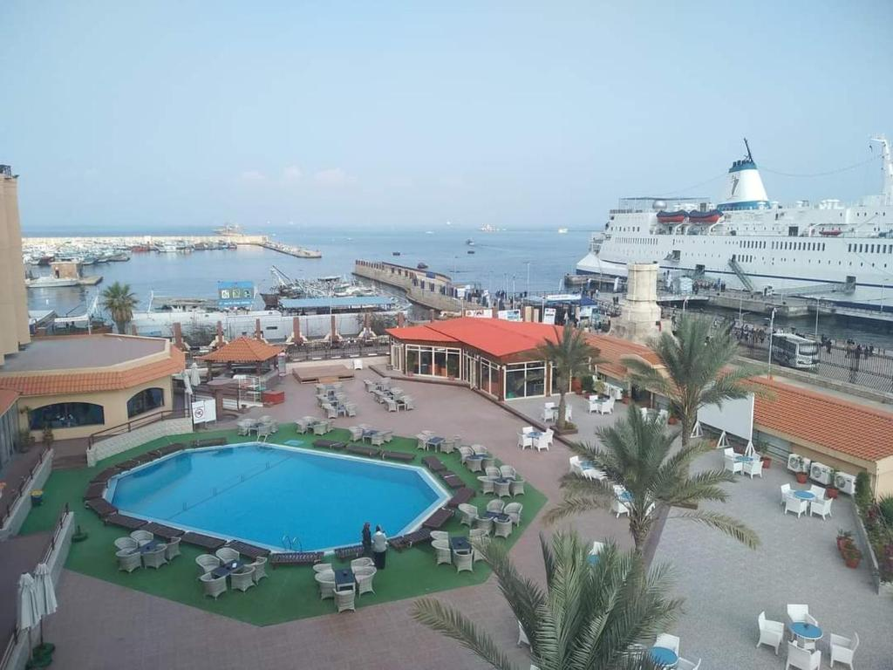

**Single Room (1700.00 EP)**

**Double Room (1900.00 EP)**

**Triple Room (2350.00(**

**Panorama Hotel (Mediterranean See and Suez Canal View)**

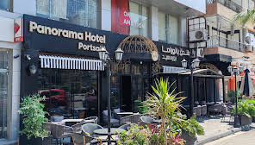 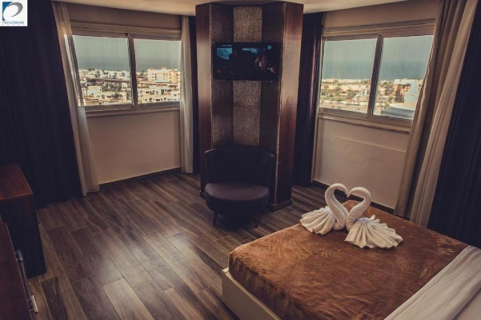

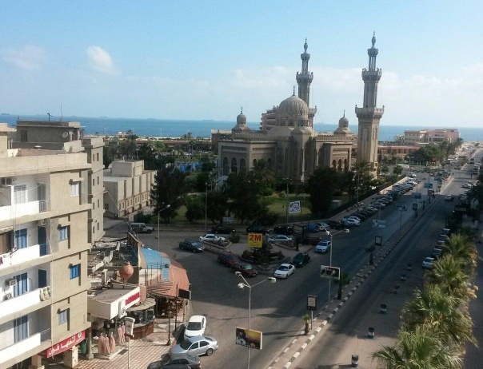 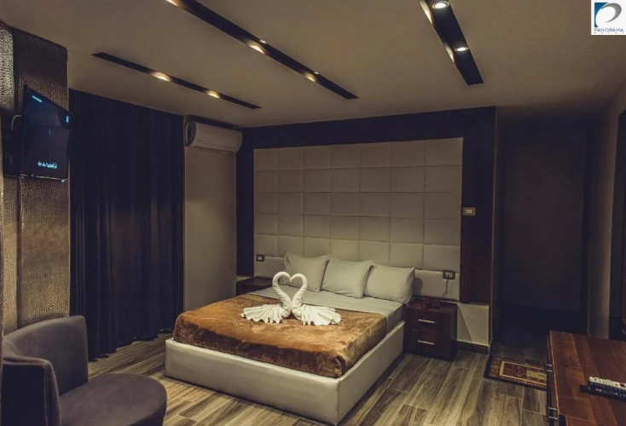

**Single Room (1500.00 EP)**

**Double Room (900.00 EP)**